Atitit sumdoc index s99

D:\000atibek\l3 sumdoc s2018 until s9

Atitit sumdoc index s99

目录

1.1. Docver dir 1

1.2. Sumdoc rzt list 2

1.3. Everhting index 2

1.4. Zip ver 2

## Docver dir

D:\000atibek\l3 sumdoc s2018 torb31 v2 t1

D:\000atibek\l3 sumdoc s2018 torb31 v2 t1

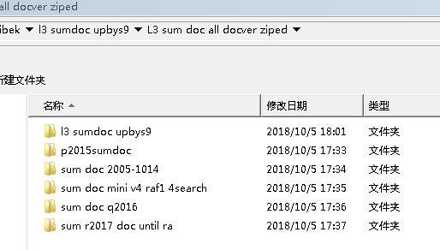

## Sumdoc rzt list



d:\\l3 sumdoc s2018 torb31 v2 t1_filelist.txt"; only s9--sb31

## Everhting index

G:\l4 sumdoc everything index 2000-20191231

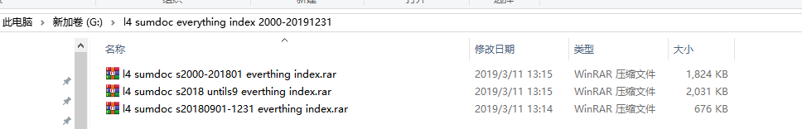

## Zip ver

D:\000atibek\l3 sumdoc s2018 until s9

